Task 1:
Data structure is a way of organizing and storing data in a computer so that it can be accessed and modified efficiently. The main purpose of data structure is to store and retrieve data efficiently. With different data structures, we can optimize the performance. It helps in solving problems with less memory usage and faster execution

Task 2:
There are linear data structures and non-linear data structures.
- Linear Data Structures
Array
ArrayList
LinkedList
Stack
Queue

- Non Linear Data Structures
Tree
Binary Tree
Graph
Trie
Heap

- Hash Based Data Structures
HashMap
HashSet
LinkedHashMap

Task 3:
Insert - Add an element
Delete - Remove an element
Search - Find an element
Access/Get - Retrieve an element without removing
Update - Modify an existing element
Traverse - Visit all elements
Sort - Arrange elements in order
Filter - Select elements based on condition
Merge - Combine two structures
Resize - Increase or decrease structure size
Clone - Duplicate the structure
Check Size - Get number of elements
Check Empty - Check if structure is empty

Task 4:

Feature | Static Array | Dynamic Array
Size | Fixed at the time of declaration | It can resize itself during runtime
Performance | Fast Access | It is slightly lower due to resizing
Memory | Efficient, no extra spaces | It will allocate extra memory upon resizing
Flexibility | Inflexible; size cannot change | Flexible; can accommodate changing data sizes
Limitations | Wastes memory if oversized, or may overflow | Overhead of resizing and copying data

Task 5:
01100001

Task 6:
1. Primary Memory

RAM : Temporary memory, fast, volatile
ROM : Permanent memory, non-volatile
Cache : Very fast, stores frequently used data
Registers : Inside CPU, smallest and fastest

2. Secondary Memory
HDD : Magnetic storage
SSD : Faster than HDD
Optical Disk : CD, DVD
Flash Drive : USB pen drive
Memory Card : microSD

3. Tertiary Memory
Magnetic Tape : Used for backups in servers

4. Virtual Memory
Uses hard disk as extra RAM when needed
Task 7:
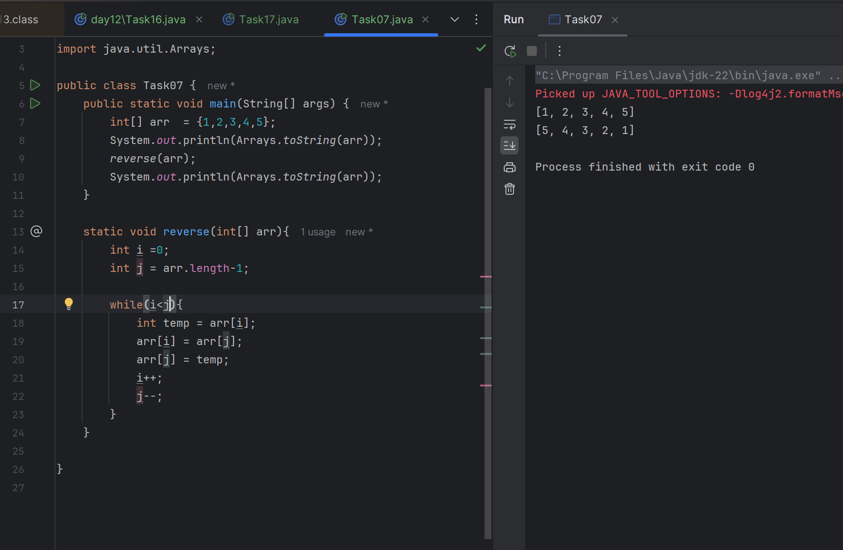

Task 08:
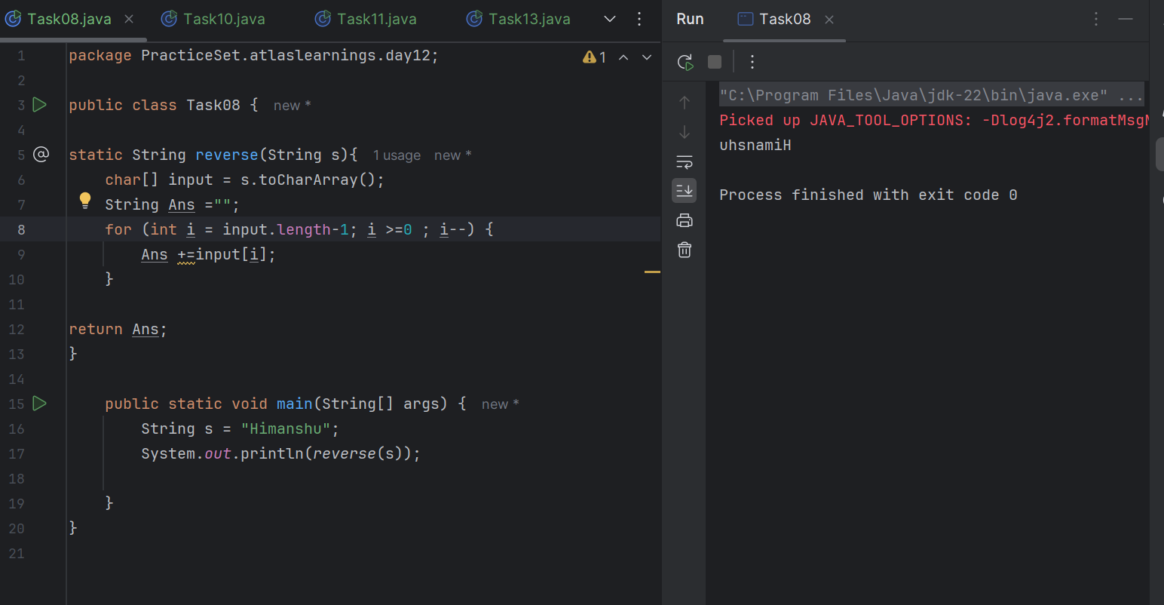
Task 09:
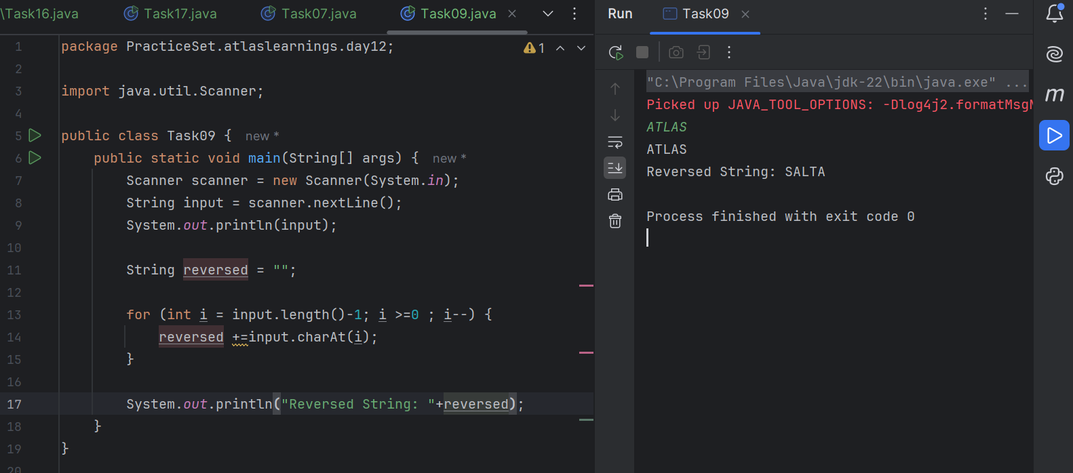

Task 10:
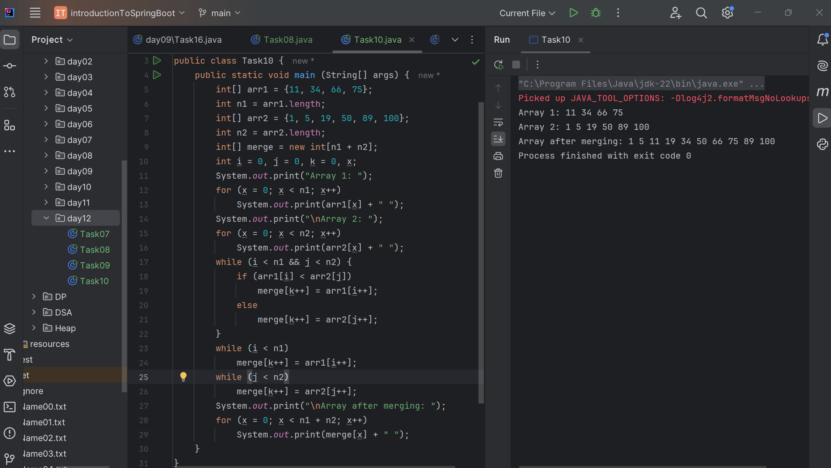

This code will merge 2 arrays in a sorted manner and if any elements are left from any of the arrays after merging, it will put remaining elements in the merged array.

Task 11:
A hashtable is a data structure used to store key–value pairs in a way that allows very fast access to data. It uses a concept called hashing to convert a key into an index, where the value is stored. Fast lookup (almost constant time: O(1)). Easy to insert, delete, and search by key

Task 12:
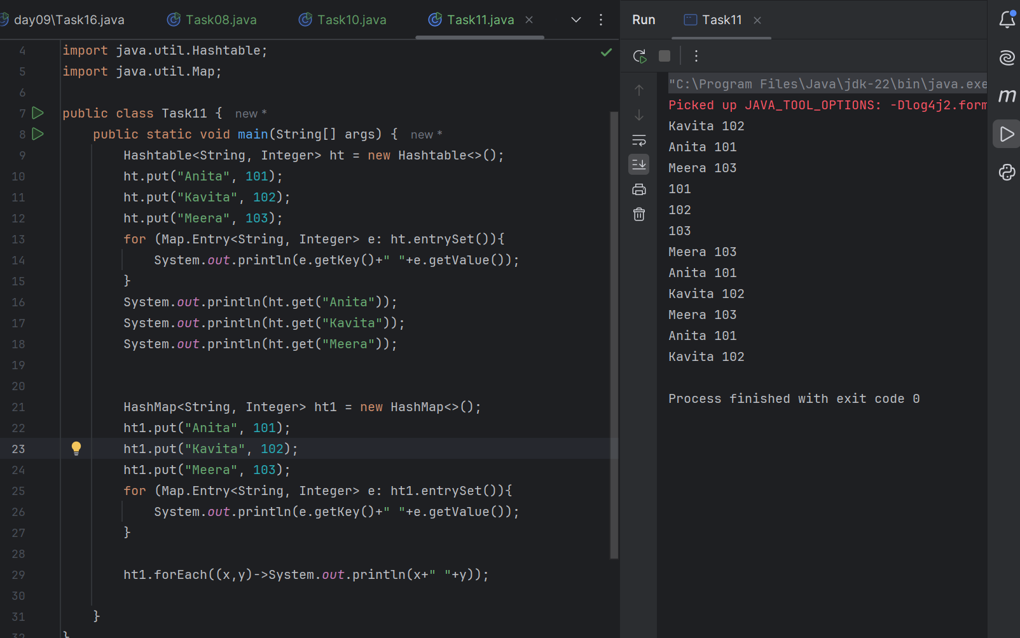

Task 13:
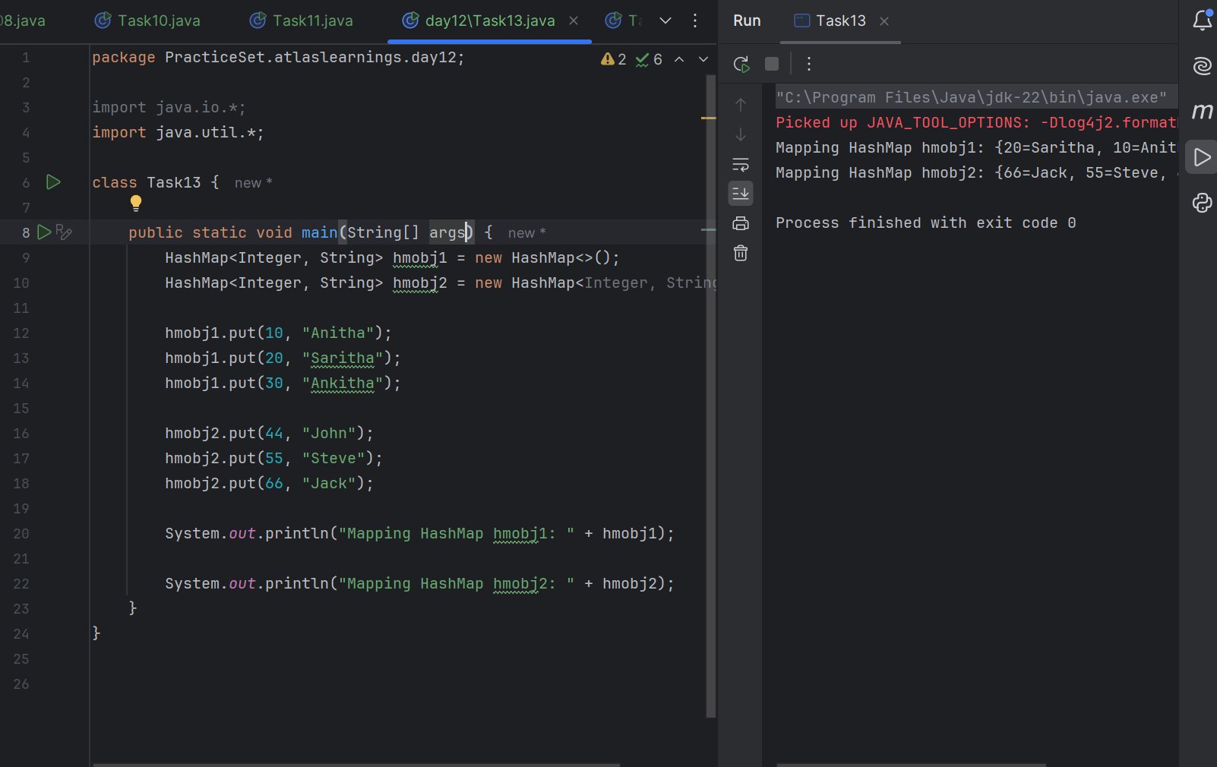

Task14:
Differences between HashTable and HashMap
HashMap is not thread-safe whereas HashTable is thread-safe.
HashMap is faster as there is no synchronization overhead whereas HashTable is slower due to synchronization.
HashMap allows one null key and one null value, whereas HashTable does not allow null keys or values.

Task 15:
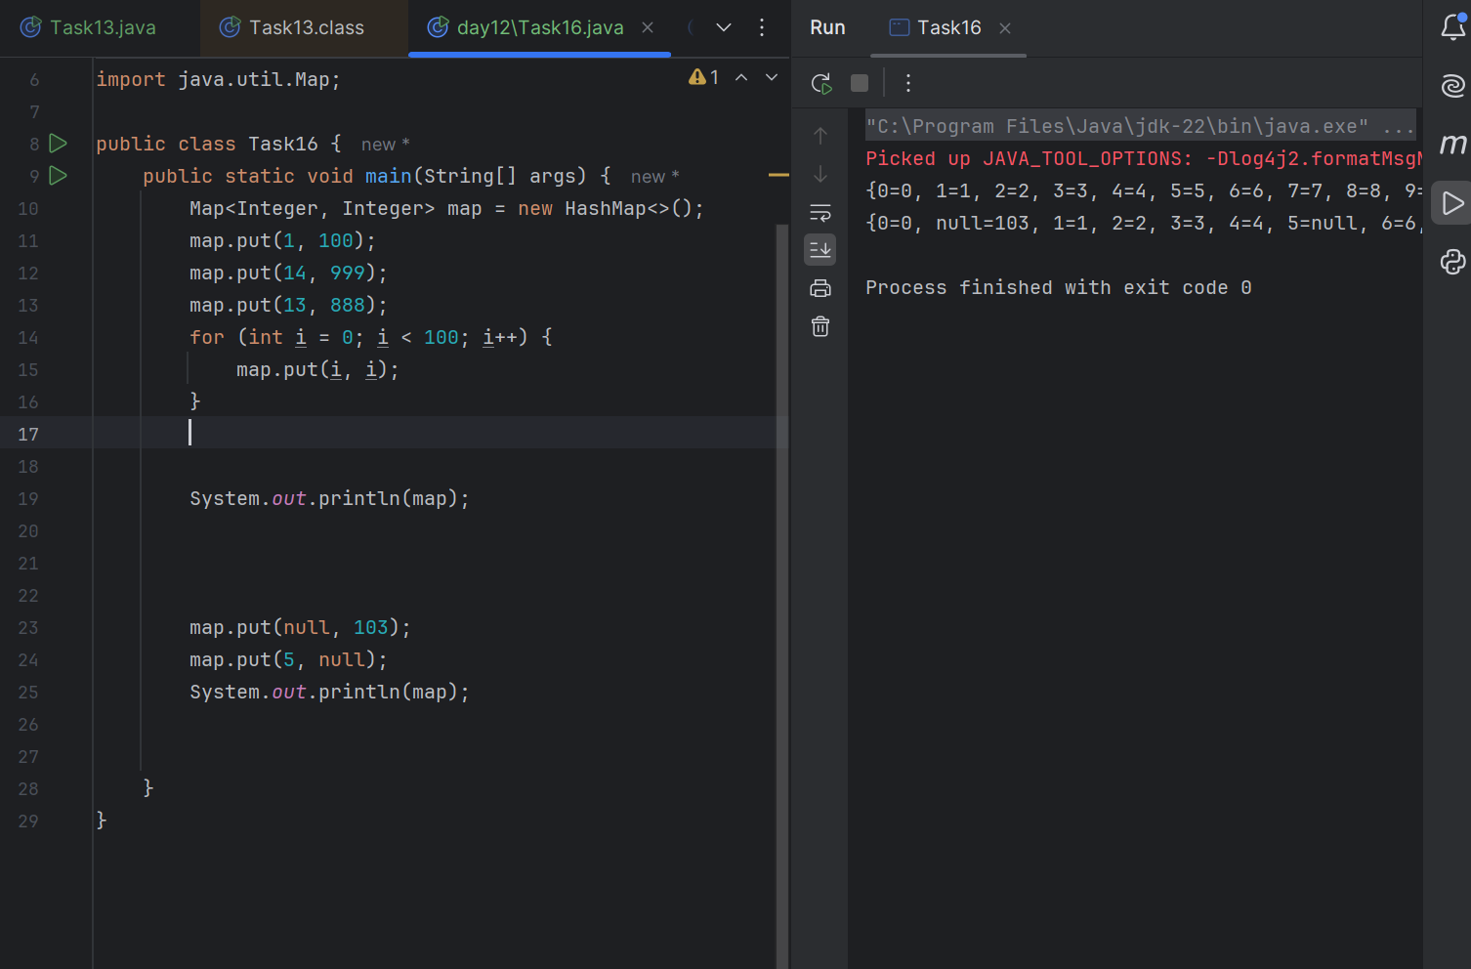

Task 16:
